Selenium automation kit execution

This doc is used to guide how to run the GS automation with Selenium automation Frame Work.

Develop Environment Setup

1. Install the JDK with the latest version.
2. Download the Eclipse classic version and extract it.
3. Install the TestNG in the eclipse.
4. In the eclipse, click “help->software updates”.
5. Click “Available Software->Add Site”, input the <http://beust.com/eclipse> in the “Location” input box.
6. Click “OK”, select the “testng” and follow the prompt.
7. When finished, restart the eclipse.
8. Copy the selenium folder “selenium-2.0b3.zip” to the plugins folder and unzip it.
9. Add the selenium client jars to the project “Build Path”.
10. Checkout selenium kit from CVS Server - \GlobalSightSource\main6\QA_Automation\Selenium
11. Create a new project in Eclipse(File->New->Java Project), input a name and point the location.

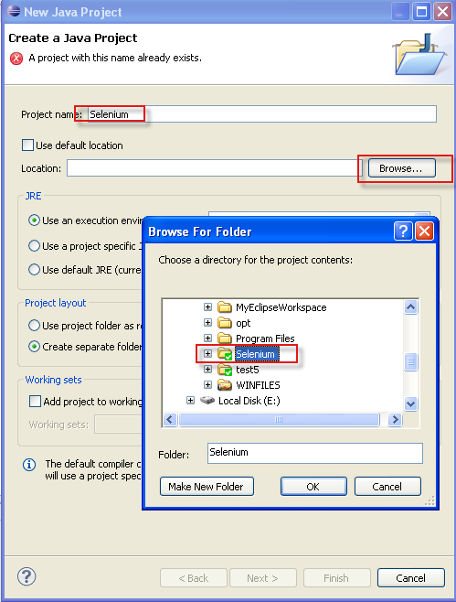

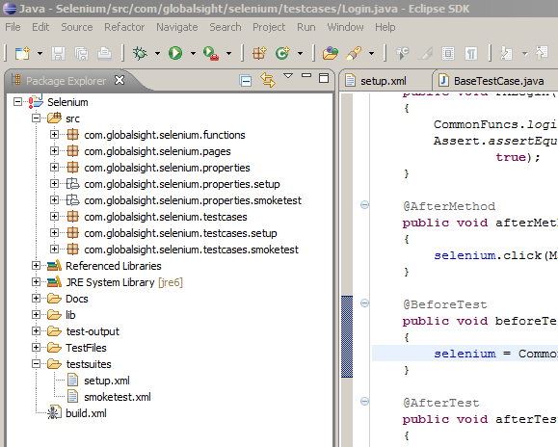

1. Explanations about kit structure –

\src\com\globalsight\selenium\functions - including the function for features

\src\com\globalsight\selenium\pages – including definition for all elements in the webpage

\src\com\globalsight\selenium\properties – including user input data, eg, name, type ..

\src\com\globalsight\selenium\testcases – including all the test cases

\test-output\ - generate the result report of automation

\ GlobalSight Automation Files\ - including all the test files in test case

\testsuites\setup.xml – including the job-related test cases

\testsuites\smoketest.xml – including the test cases about the basic operations, such as new, edit, remove…

\build.xml – entry of automation test. User can right click the “Build.xml” and select “run as->Ant Build”.

Server and Firefox Configuration

**Notes:** It’s recommended to run the testcases with firefox 3.x

1. Copy the selenium folder “selenium-2.0b3.zip” to the one system (where you want to run automation) folder and unzip it. For example(C:\selenium-2.0b3)

Copy the directory “GlobalSight Automation Files” to the system, for example (C:\GlobalSight Automation), and share the directory, the files in this directory are used for running automation.

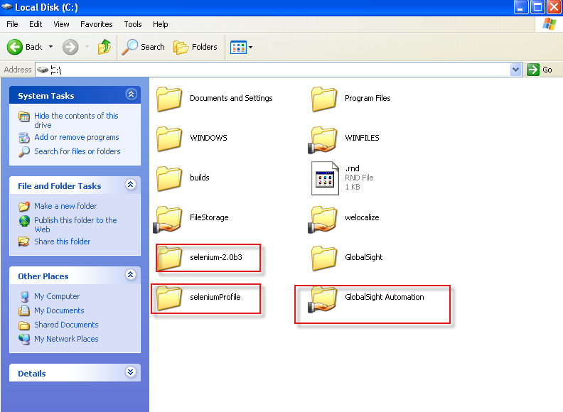

1. Open “cmd” command, navigate to firefox installation directory, and input “firefox -p”

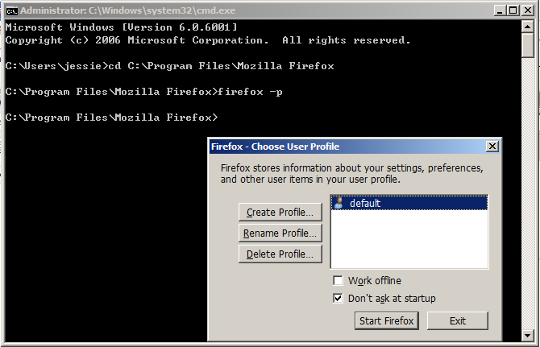

1. Click Create Profile…

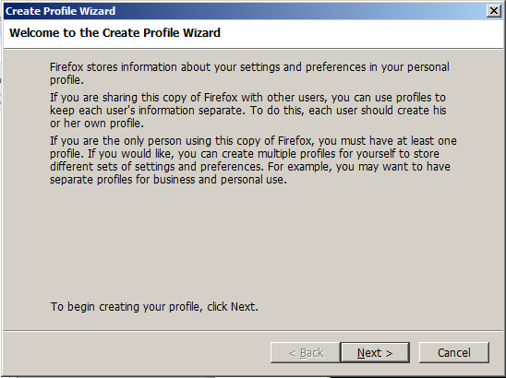

1. Click Next, Input a new profile name, like “selenium”. Select a file folder for example(C:\seleniumProfile) and Then Click Finish

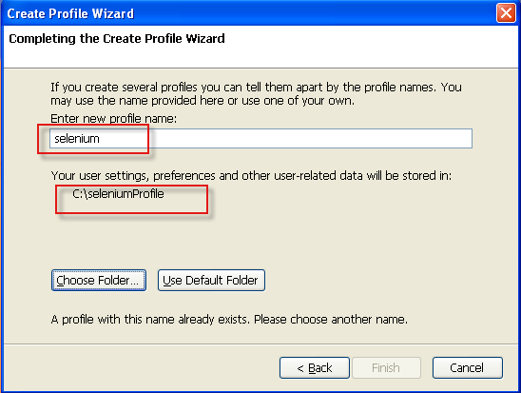

1. Click Start Firefox with newly created firefox profile.

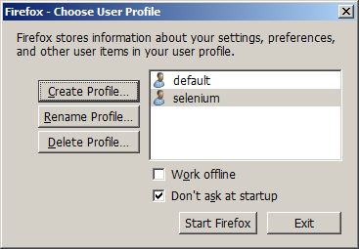

1. Set the default download location with options –

“Save files to” is the folder you created in step 1

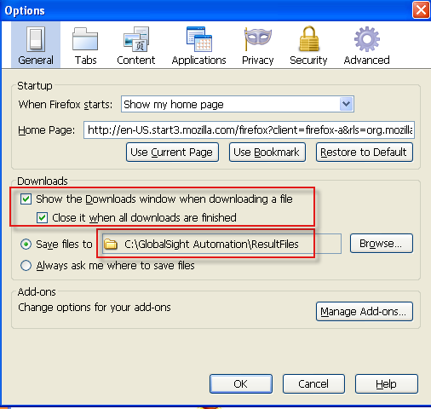

To make sure Firefox could download file without any dialog, you should make the configurations as below:

Log one GlobalSIght Server and export some file, set the options like

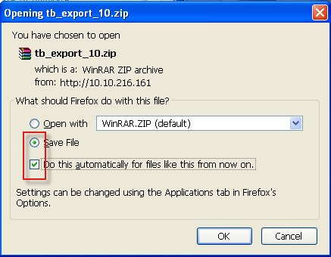

This operation must be done for all the downloaded format files in our automation test case.

Make sure all downloaded file format listed in the Applications with Save File. Like below

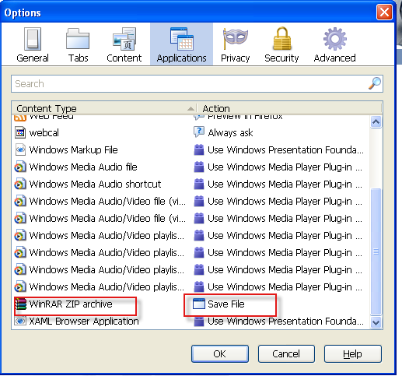

After that, you can close firefox.

1. Run the server.

Run the command “cmd”, the run the command as below:

“java -jar <Server Path> -firefoxProfileTemplate <firefox profile path> -port <port>”

for example

java -jar C:\selenium-2.0b3\selenium-server-standalone-2.0b3.jar -firefoxProfileTemplate C:\seleniumProfile -port 3333

Preparation before run automation test (Properties)

1. “\src\com\globalsight\selenium\properties\ConfigData.properties”, this properties file is very import, you must specify the server ip, for example:

######################System configuration######################

######GlobalSight Server############

SERVER_URL = http://10.10.216.161:80

######SELENIUM Server###############

SELENIUM_HOST = 10.10.216.161

SELENIUM_PORT = 3333

######Base_Path:save the test files, the directory is in SELENIUM Server######

Base_Path = \\\\10.10.216.161\\GlobalSight Automation\\TestFiles\\

######Base_Path_Result:save the result files from GlobalSight(i.e. TB export files), the directory is in SELENIUM Server########

Base_Path_Result = \\\\10.10.216.161\\GlobalSight Automation\\ResultFiles\\

######BROWSER:Browser type to run automation######

BROWSER = *firefox

######other configuration############

……

1. Other properties need to edit according to your test need

src\com\globalsight\selenium\properties\smoketest\CreateProject.properties (pm user info)

\src\com\globalsight\selenium\properties\smoketest\PrepareCreatingJob.properties (pm user info and new user info)

……

Run Automation

1. Change the testng.xml file if you want to configure the test cases information.
2. In Eclipse, right click the “smoketest.xml” file and select “run as🡪 TestNG Suite”.

Or you can right click the “Build.xml” and select “run as->Ant Build”.

Also, debug is ok.

1. You can check the result at the “test-output” folder.

Coding

1. Naming rules：
2. Add a suffix “BUTTON” to Button definition. Such as “OK_Button=’ok’”.
3. Add a suffix “MENU” or “SubMenu” to menu definition.
4. Add a suffix “CHECKBOX” to Check Box definition.
5. Add a suffix “RADIO” to Radio Button definition.
6. Add a suffix “TEXT_FIELD” to Text Field definition.
7. Add a suffix “TEXT” to Text Box definition.
8. Add a suffix “LABEL” to Label definition.
9. Add a suffix “SELECT” to select definition.